*Logic Specification Template*

|  |  |  |  |
| --- | --- | --- | --- |
| **Student** | Lucía Cantú-Miller | **Program #** | 6 |

|  |  |
| --- | --- |
| **Class Name** | Simpson |

|  |  |
| --- | --- |
| **Method Name** | SimpsonRule |

|  |  |
| --- | --- |
| **Parameters** |  |
|  |  |

**Include the image of the activity diagram created for the program:**

|  |  |
| --- | --- |
| **Class Name** | Simpson |

|  |  |
| --- | --- |
| **Method Name** | CalculateDiference |

|  |  |
| --- | --- |
| **Parameters** |  |
|  |  |

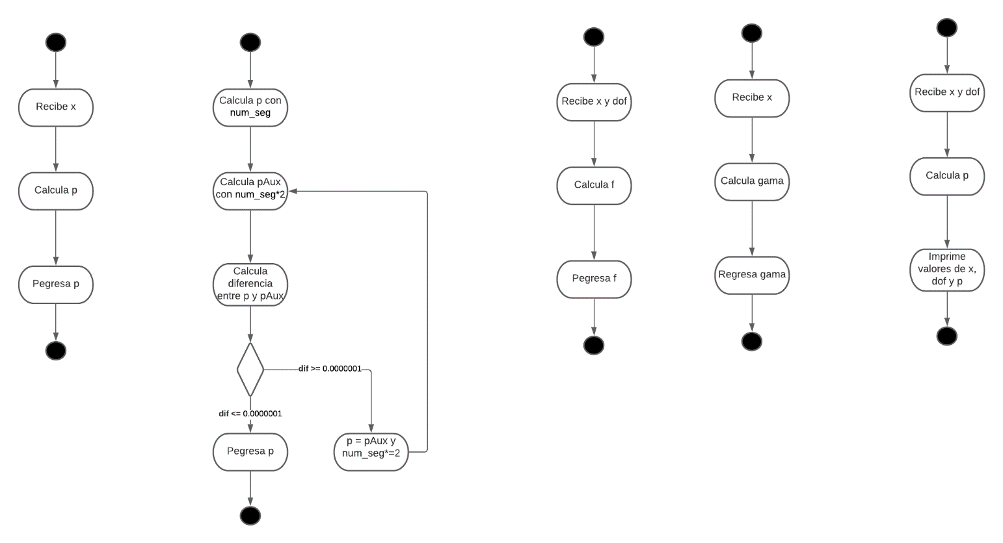

**Include the image of the activity diagram created for the program:**

|  |  |
| --- | --- |
| **Class Name** | Simpson |

|  |  |
| --- | --- |
| **Method Name** | getSimpson |

|  |  |
| --- | --- |
| **Parameters** | x |
|  | dof |

**Include the image of the activity diagram created for the program:**

|  |  |
| --- | --- |
| **Class Name** | Distribution |

|  |  |
| --- | --- |
| **Method Name** | Dist |

|  |  |
| --- | --- |
| **Parameters** | x |
|  | dof |

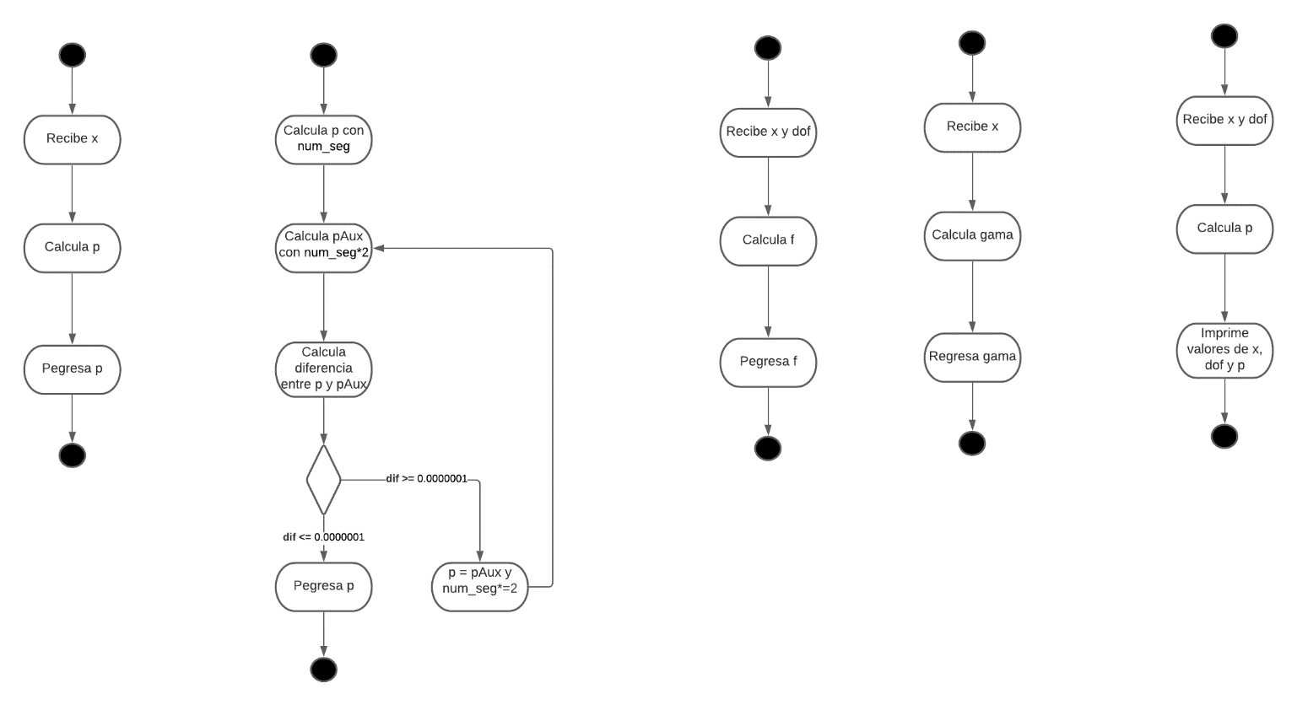

**Include the image of the activity diagram created for the program:**

|  |  |
| --- | --- |
| **Class Name** | Distribution |

|  |  |
| --- | --- |
| **Method Name** | Gamma |

|  |  |
| --- | --- |
| **Parameters** | x |
|  |  |

**Include the image of the activity diagram created for the program:**

|  |  |
| --- | --- |
| **Class Name** | Main |

|  |  |
| --- | --- |
| **Method Name** | Main |

|  |  |
| --- | --- |
| **Parameters** |  |
|  |  |

**Include the image of the activity diagram created for the program:**

|  |  |
| --- | --- |
| **Class Name** | Regression |

|  |  |
| --- | --- |
| **Method Name** | BOne |

|  |  |
| --- | --- |
| **Parameters** | xySum, xAvg, yAvg |
|  | xSumSqrd, n |

**Include the image of the activity diagram created for the program:**

|  |  |
| --- | --- |
| **Class Name** | Regression |

|  |  |
| --- | --- |
| **Method Name** | BZero |

|  |  |
| --- | --- |
| **Parameters** | xAvg, yAvg |
|  | bOne |

**Include the image of the activity diagram created for the program:**

|  |  |
| --- | --- |
| **Class Name** | Correlation |

|  |  |
| --- | --- |
| **Method Name** | CalcCorrelation |

|  |  |
| --- | --- |
| **Parameters** | xySum, xSum, ySum, xSumSqr |
|  | ySumSqr, n |

**Include the image of the activity diagram created for the program:**

|  |  |
| --- | --- |
| **Class Name** | CalcHelper |

|  |  |
| --- | --- |
| **Method Name** | XYSum |

|  |  |
| --- | --- |
| **Parameters** | xValues, yValues |
|  | n |

**Include the image of the activity diagram created for the program:**

|  |  |
| --- | --- |
| **Class Name** | CalcHelper |

|  |  |
| --- | --- |
| **Method Name** | Average |

|  |  |
| --- | --- |
| **Parameters** | Values |
|  | n |

**Include the image of the activity diagram created for the program:**

|  |  |
| --- | --- |
| **Class Name** | CalcHelper |

|  |  |
| --- | --- |
| **Method Name** | Sum |

|  |  |
| --- | --- |
| **Parameters** | Values |
|  | N |

**Include the image of the activity diagram created for the program:**

|  |  |
| --- | --- |
| **Class Name** | CalcHelper |

|  |  |
| --- | --- |
| **Method Name** | SumSqrd |

|  |  |
| --- | --- |
| **Parameters** | Values |
|  | n |

**Include the image of the activity diagram created for the program:**

|  |  |
| --- | --- |
| **Class Name** | CalcHelper |

|  |  |
| --- | --- |
| **Method Name** | SumTwoNumbersSqrd |

|  |  |
| --- | --- |
| **Parameters** | values, n |
|  | average |

**Include the image of the activity diagram created for the program:**

|  |  |
| --- | --- |
| **Class Name** | CalcHelper |

|  |  |
| --- | --- |
| **Method Name** | GetX |

|  |  |
| --- | --- |
| **Parameters** | p |
|  | dof |

**Include the image of the activity diagram created for the program:**

|  |  |
| --- | --- |
| **Class Name** | CalcHelper |

|  |  |
| --- | --- |
| **Method Name** | StandardDeviation |

|  |  |
| --- | --- |
| **Parameters** | xValues, yValues, |
|  | bZero, bOne, n |

Por medio de este párrafo yo Lucía Cantú-Miller certifico que soy el autor intelectual del material que arriba entrego y que no realicé una copia de ninguna otra persona. En aquellos casos en los que tuve que incluir material de otra persona, reporté su apropiada referencia.